FRANCIS XAVIER ENGINEERING COLLEGE – TIRUNELVELI
DEPARTMENT OF ELECTRICAL AND ELECTRONICS ENGINEERING
ADDRESS BOOK
BATCH: 2013 – 2017 IV EEE –B
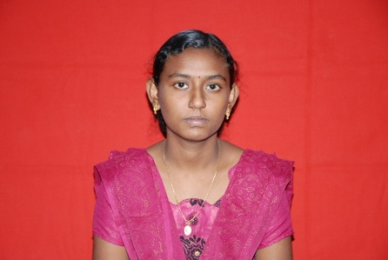 | Name : NARMATHA.M  Address : D/O N.MUTHUSAMY  59,ARUNACAHALAPURAM,  KAYALPATTINAM  THOOTHUKUDI 658204  Dob : 31.10.1995  Email Id : aarthyvenkatakrishnan@gmail.com  Contact no : 9442052005
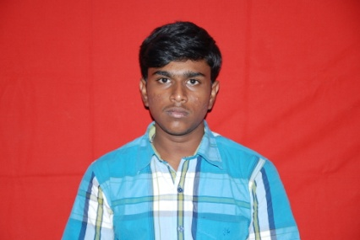 | Name : NAVEEN.K.K.H  Address : S/OK.KANNAN  NO .1 RAJENDRA NAGAR  5TH STREET  TIRUNELVELI 627002  Dob : 12.05.1996  Email Id : slimshadyjr750@gmail.com  Contact no : 9095360015
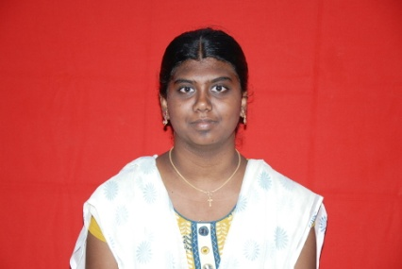 | Name : NISHA.J  Address : D/O J.JESUDURAI  169/13 AMBAI ROAD  HAPPY COLONY MELAPALAYAM  TIRUNELVELI  Dob : 19.05.1996  Email Id : nishapushpa999@gmail.com  Contact no : 9487946691
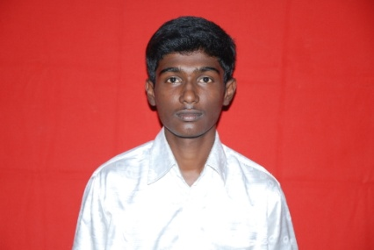 | Name : PAUL PRAVIN.M  Address : S/O P.MANI  19/1 SOUTH KALADI STREET  PULIANGUDI SIVAGIRI(TK)  TIRUNELVELI 627855  Dob : 21.11.1995  Email Id : manipravinj@gmail.com  Contact no : 8940185143
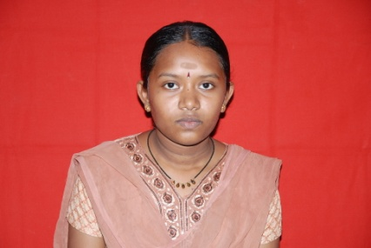 | Name : PAVITHRA.M  Address : D/O S.MARIAPPAN  10/164 THERKUMALAI COLONY  KEELATHENKULAM THENKULAM  TIRUNELVELI 627357  Dob : 11.2.1996  Email Id : srjpavithram@gmail.com  Contact no : 8940713230
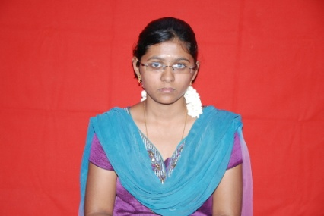 | Name : PAVITHRA.R  Address : D/O C.RAJENDRAN  181/6A MUTHAMIL STREET  K OKKIRAKULAM  Dob : 10.06.1996  Email Id : pavisaran10@gmail.com  Contact no : 9655312631
 | Name : PONSUBRAMANIAN.S  Address : S/o P.SANKARA NARAYANAN  7, PERUMAL SOUTHMADA STREET  PALAYAMKOTTAI  TIRUNELVELI  Dob : 19.3.1996  Email Id : ponsubramanianmani@gmail.com  Contact no : 9262060775
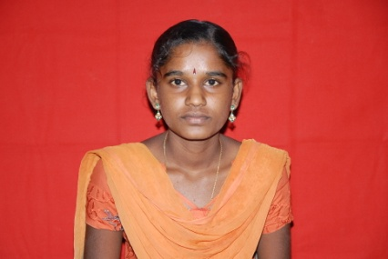 | Name : PRAVEENA.R  Address : D/o P.RAMAKRISHNAN  1\85 SOUTH STREET PARUTHIKULAM  RAJAPUTHUKUDI  TIRUNELVELI 627352  Dob : 25.5.1996  Email Id : praveenatvl@gmail.com  Contact no : 9629956479
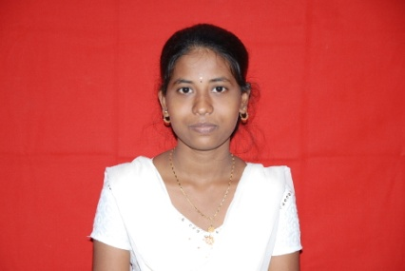 | Name : PREETHI.S  Address : D/o E.SELVAMANI  23/B ,DHALAPATHISAMUTHIRAM()  SOUTH STREET KOVANERI  ISAMUTHIRAM(PO) TIRUNELVELI  Dob : 14.10.1995  Email Id : malamani1712@gmail.com  Contact no : 9788035328
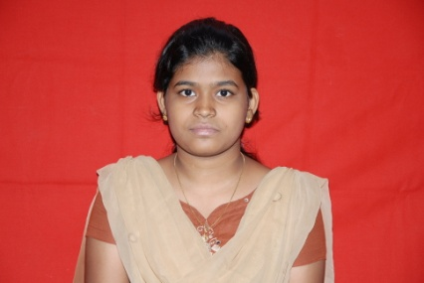 | Name : PREETHI CHRISTIAN.J  Address : D/o S.JOEL KUMAR  1 APPAVO DRAWING MASTER ST  MURUGANKURICHI,  PALAYAMKOTTAI TIRUNELVELI  Dob : 19.10.1995  Email Id : preethijoel1995@gmail.com  Contact no : 9791745762
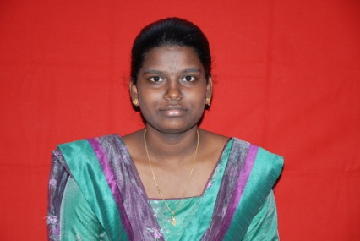 | Name : PRIYA.R  Address : D/o E.RAMA  2/304 SOUTH STREET,  VALLAVAN KOTTAI AMMUR  MADAHAVAKURICHI  TIRUNELVELI 627201  Dob : 15.12.1995  Email Id : priya3ramar@gmail.com  Contact no : 7708312652
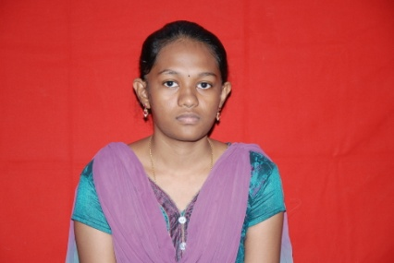 | Name : PRIYA.S  Address : D/o P.SEENISAMY  581 A,NGO A COLONY  ANNASALAI SAMKARANKOVIL  TIRUNELVELI P.SEENISAMY  Dob : 04.03.1996  Email Id : priyadazling25@gmail.com  Contact no : 7339168699
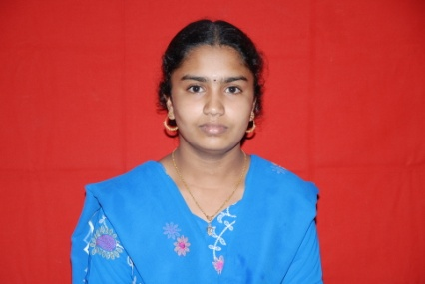 | Name : RAJALAKSHMI.S  Address : D/o P.SATHIYA MOORTHY  2-103 WEST ST 627859  KADAYALURUTTI  SANKARANKOVIL(TK)  TIRUNELVELI  Dob : 04.06.1996  Email Id : rajalakshmi4696@gmail.com  Contact no : 8973877569
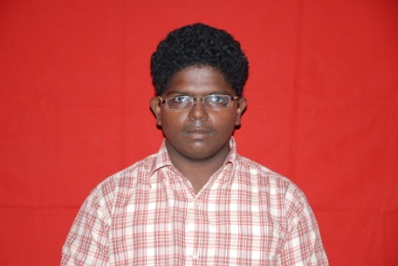 | Name : RAMA CHANDRAN.V  Address : S/o S.VELMURUGAN  5/2121, AMBEDKAR NORTH 1ST ST  (OPP) H.W.PP COLONY ,  MUTHIAH PURAM  TUTICURIN 628005  Dob : 12.11.1995  Email Id : raviramar626@gmail.com  Contact no : 9524840464
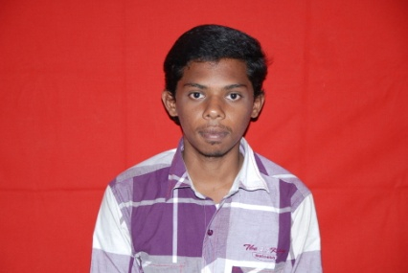 | Name : RAMKUMAR @SANKAR.A  Address : F/o ARUNACHALAM  9,SELVAVIGNESH NAGAR  MALLIGAIMIDDLE ST  THACHANALLUR  TIRUNELVELI 627358  Dob : 14.11.1995  Email Id : ramkumararunsankar@gmail.com  Contact no : 9944628769
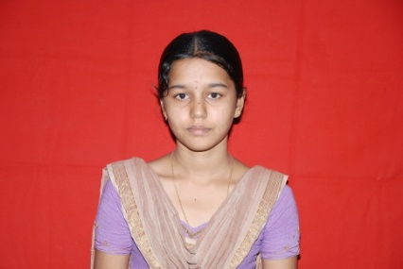 | Name : RAMYA .S  Address : M/o S.RAJESWARI  2/54 PERUMAL KOVIL STREET  PANNAIAYR COMPOUND RETTIYARPATTI  TIRUNELVELI 627007  Dob : 12.09.1995  Email Id : ramyavisva012@gmail.com  Contact no : 8940347654
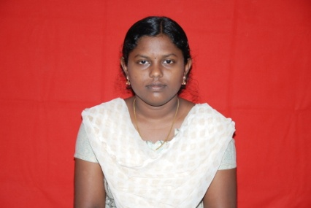 | Name : ROMITHA PRIYADHARSHINI.M  Address : D/o D.Michel Antony  8\208A MAIN ROAD WEST STREET ,  DURAIYOOR,  GANGAIKONDAN(PO)  Tirunelveli 627352  Dob : 19.02.1996  Email Id : romithamicheal@gmail.com  Contact no : 9488421107
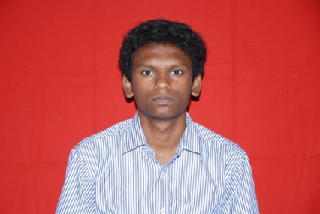 | Name : RUSWIN.R  Address : F/o S.P.RAJA  10/2 MIDDLESTREET UVARI  TIRUNELVELI 627352  Dob : 18.11.1995  Email Id : ruswin1995@gmail.com  Contact no : 9750082385
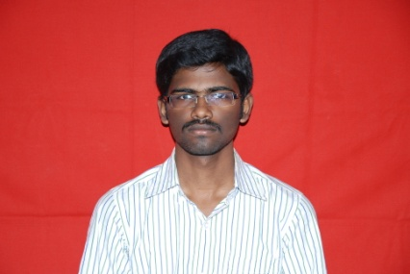 | Name : SAKTHI RAM.D.G  Address : F/o R.DURAI PAZHAM  18/3 TYPE II CAMP II  ANALMIN NAGAR  TUTICORIN 628004  Dob : 04.11.1995  Email Id : dgsakthirameee@gmail.com  Contact no : 9688192824
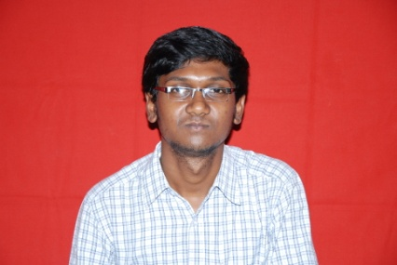 | Name : SANKARA SRINIVASAN.K  Address : F/o S.KUTTA LINGAM  5A/3 JOTHINAGAR  4TH STREET WEST EXT  KOVILPATT I  Dob : 29.12.1995  Email Id : sankara95sri@gmail.com  Contact no : 7845611404
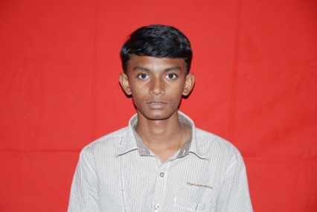 | Name : SANTHANA MARIAPPAN .E  Address : F/o S.ESAKKIAPPAN  144 RAJAPILLAI LANE  NORTH CAR STREET  TUTICORIN 628002  Dob : 28.02.1996  Email Id : savens7v3@gmail.com  Contact no : 9789516778
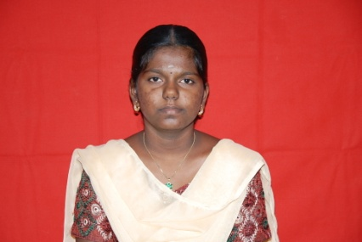 | Name : SANTHIYA.R  Address : F/o K.RAJENDRAN  2/166 WEST STREET  KADAYALURUTTI SANKARANKOVIL(TK)  TIRUNELVELI 627859  Dob : 05.05.1996  Email Id : rgssthiyarajendran@gmail.com  Contact no : 9843459970
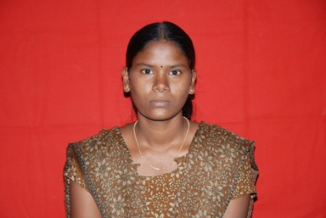 | Name : SARANYA.S  Address : F/oS.SELVARAJ  2/59 ESWARI AMMAN KOIL STREET  MUNER PALLAM  TIRUNELVELI 627356  Dob : 23.03.1996  Email Id : saranyawhite01@gmail.com  Contact no : 8012275781
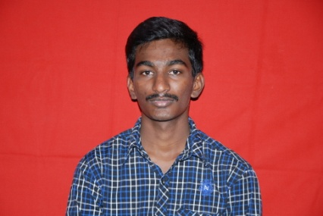 | Name : SASITHARAN.C  Address : F/o N.CHELLA DURAI  2/97 PILLAYAR KOVIL STREET  KUNNATHUR  TIRUNELVELI 627006  Dob : 25.12.1995  Email Id : sasitharan25121995@gmail.com  Contact no : 9790495428
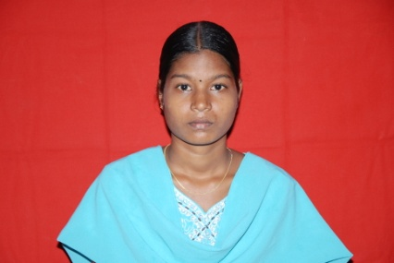 | Name : SATHIYA.M  Address : F/o S.MARIMUTHU  2/144 SHANMUGAVILAS ST,  KEELANATHAM MELUR PALAYAMKOTTAI  TIRUNELVELI 627353  Dob : 21.04.1996  Email Id : sathiyamarimuthu21496@gmail.com  Contact no : 7373453172
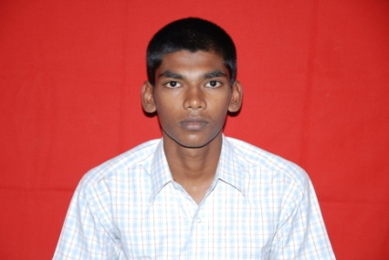 | Name : SELVAKUMAR.G  Address : F/o C.GANDHI  1/2 NORTH STREET PARUTHIKULAM  GANGAIKONDAN  TIRUNELVELI 627352  Dob : 26.04.1996  Email Id : gandhikasi94@gmail.com  Contact no : 8508526364
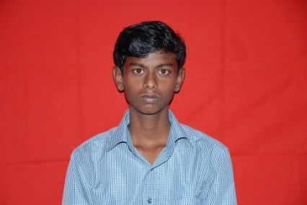 | Name : SENTHOORAPANDI.G  Address : 1/439,PULLANGUDI(PO) PULLAGUDI  RAMANATHAPURAM  Dob : 02.06.1996  Email Id : psenthoora@gmail.com  Contact no : 9566303785
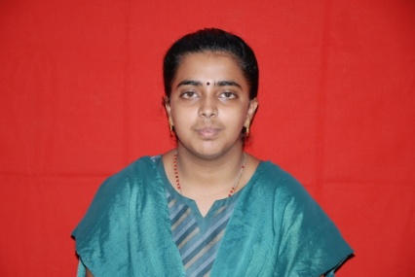 | Name : SHAMMA AROKIA MARIA RAYAMAL.A  Address : F/o A.ANTONY MADHAVADIAN1  7, RAMALINGAR STREET  KOVILPATTI  TUTICURIN 628501  Dob : 22.01.1995  Email Id : shammaj22@gmail.com  Contact no : 8124290642
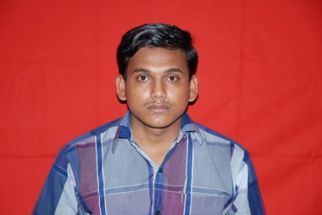 | Name : SHANMUGA PANDIAN .P  Address : F/o R.POTHIYAPPAN  2/4 BAGAVATHI AMMANSOUTH STREET  THIRUVETANALLUR- 627855  Dob : 27.04.1996  Email Id : shanmugaraj@gmail.com  Contact no : 9787371839
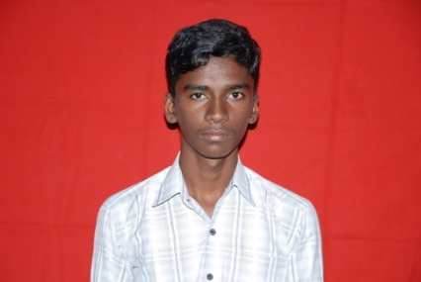 | Name : SIVANANTHAM.K  Address : F/0 S.KASIPANDI  4/331 NORTH ST  RUKUMANIAMMALPURAM  V.K.PUDUR  TIRUNELVELI 627860  Dob : 17.09.1995  Email Id : fxsiva777@gmail.com  Contact no : 8220145564
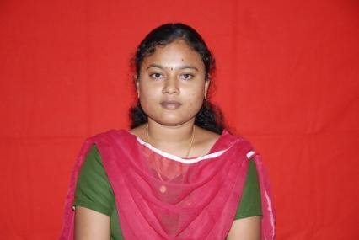 | Name : SIVANIRUBAMA.S  Address : F/o P.SATHYA NARAYANAN  11/162/27  SANTHANAKUMARI ILLAM CIRCLE OFFICE  1ST STREET SANKAR NAGAR  TIRUNELVELI 627357  Dob : 18.10.1994  Email Id : sivaniru1994@gmail.com  Contact no : 9578479458
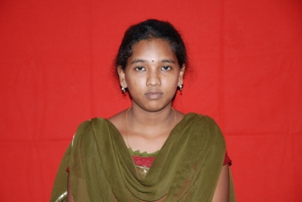 | Name : SIVARANJANI.N  Address : F/o A.NESAMANI  2/58-8 J.J NAGAR  VEEERAPANDIAPATTINAM  TIRUCHENDUR 628215  Dob : 23.08.1995  Email Id : ranjiidini@gmail.com  Contact no : 7449017411
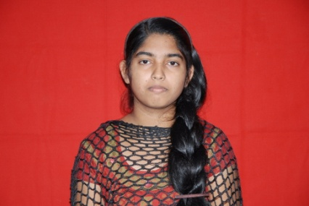 | Name : STEPHY.K.JOHNSON  Address : F/o JOHNSON VARGHESE  PURAIKATTU HOUSE  PANDANAD(PO) CHENGANNUR  ALAPPUZHA(DT) 689506  Dob : 08.12.1994  Email Id : stephyjohnson61@gmail.com  Contact no : 7845170099
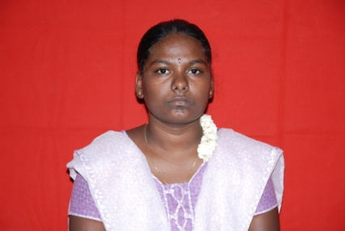 | Name : SUBAANANTHI.M  Address : F/o A.MARIAPPAN  2\86 KEELAAKLLUR COLONY  M.G.R NAGAR KALLUR  TIRUNELVELI 627010  Dob : 28.01.1996  Email Id : sakthisuba2906@gmail.com  Contact no : 9095235504
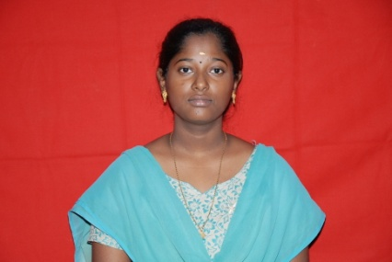 | Name : SUBBULAKSHMI.A  Address : F/0 S.ARUMUGAM  7\B ARUNACHALAM ST ,  GOPALASAMUDRAM AMBASAMUDRAM(TK)  TIRUNELVELI  Dob : 02.10.1995  Email Id : subbulakshmiarumugam95@gmail.com  Contact no : 9489488661
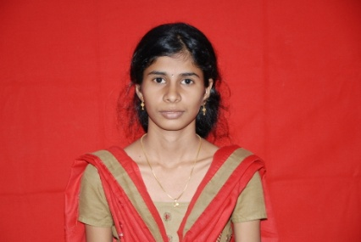 | Name : SUBHA LAKSHMI.R  Address : F/o V.RAMASAMY  85 AATHIYADI ILLATHUR ST  KALLIDAIKURUCHI 627416  Dob : 05.01.1996  Email Id : r.subha1996@gmail.com  Contact no : 9488881996
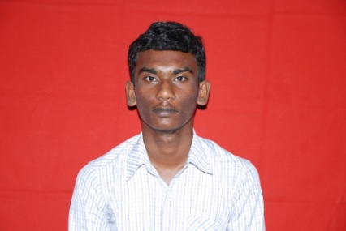 | Name : SUDALAIMUTHU.A  Address : F/o S.ARUMUGAM  4A KALIAMMAN KOVIL STREET KAYATHAR  TIRUNEVELI 62895  Dob : 04.05.1995  Email Id : muthusudalai313@gmail.com  Contact no : 9994740467
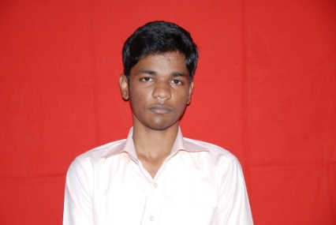 | Name : SUNDAR.C  Address : F/o S.CHINNA DURAI  1B/1 MAIN STREET VEERAMANIAPURAM  TIRUNELVELI 627005  Dob : 25.05.1996  Email Id : harisundar030@gmail.com  Contact no : 9487173767
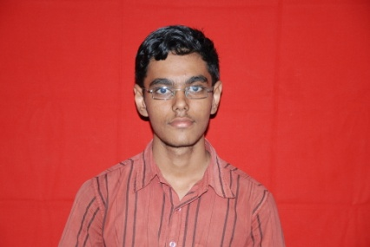 | Name : SUNDARAM @ SANTHOSH .B  Address : F/o S.BALASUBRAMANIAN  1-B SUNDARAR ST  TIRUNELVELI TOWN  Dob : 07.08.1995  Email Id : sundaramsanthosh7@gmail.com  Contact no : 9787275381
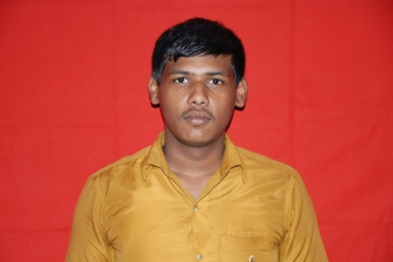 | Name : SURESH KANNAN.V  Address : F/o S.VADIVEL  90-2A AYYAPAN NAGAR  KTC NAGAR  TIRUNELVELI  Dob : 06.11.1995  Email Id : vadivelsuresh97@gmail.com  Contact no : 9444231578
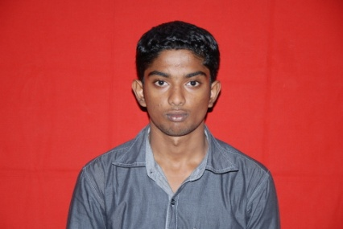 | Name : SURESH KUMAR.S  Address : S.SUKUMARAN  F/o SURESH KUMAR.S  11 AMBIKAPURAM NORTH STREET  MELAPALAYAM  TIRUNELVELI  Dob : 21.03.1995  Email Id :  Contact no : 9447135548
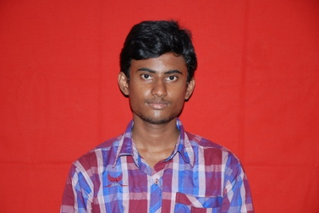 | Name : SYFUL ISLAM.Y  Address : F/o M.A.YOUSUF  67/30A PERIYAKOTTHA PALLIVASAL  NORTHWEST STREET  MELAPALAYAM  TIRUNELVELI  Dob : 24.11.1995  Email Id : syfulislamy@gmail.com  Contact no : 8608114561
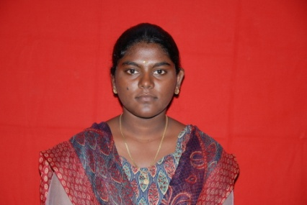 | Name : TAMIL SELVI.S  Address : F/o T.SIVA PERUMAL  2/42B AMMAN KOVIL STREET  NANJANKULAM  NANJANKULAM(PO) SANKARNAGAR(VIA)  TIRUNELVELI 627002  Dob : 22.11.1995  Email Id : tamilselvi221195@gmail.com  Contact no : 7708748441
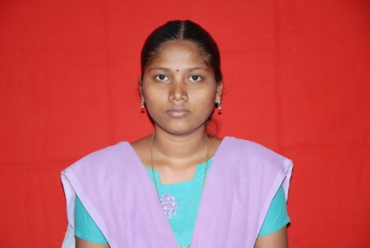 | Name : UMA.G  Address : M/o G.SUBBU LAKSHMI  62/120  SOUTHSTREET VOC NAGAR  TIRUNELVELI  Dob : 24.06.1994  Email Id : uma1994@gmail.com  Contact no : 7418878246
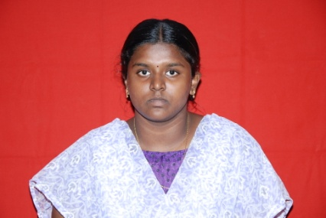 | Name : VALARMATHI.P  Address : F/o A.PANNIRUKAI PERUMAL  H/5A RAGEVENDRA NILAYAM TNHB COLONY  STAGE III NEAR DEPO,  V.MCHATHIRAM  TIRUNELVELI  Dob : 06.04.1996  Email Id : valarmathi06041996@gmail.com  Contact no : 7401060270
 | Name : VENKATESH.G  Address : F/oM.GOPAL  18 A EAST STREET  VANNARPETTAI  TIRUNELVELI  Dob : 05.06.1995  Email Id : venkat@gmail.com  Contact no : 7871758818
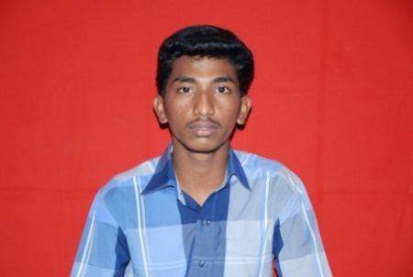 | Name : VIGNESH .S(27.03.1996)  Address : F/o M.SANKAR  28/13 A VOC STREET  KAYATHAR 628952  Dob : 27.03.1996  Email Id : vickyganesh54@gmail.com  Contact no : 8056752598
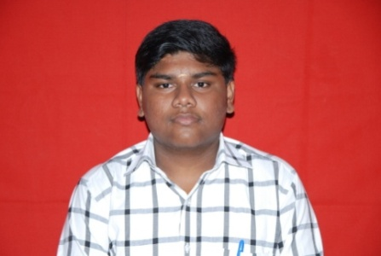 | Name : VIGNESH.A  Address : F/oS.ARUMUGAM  17 CATHEDRAL COLONY  REDDAIYARPATTI NGO a COLONY  TIRUNELVELI 627007  Dob : 29.08.1995  Email Id : skyhighvignesh95@gmail.com  Contact no : 8056474100
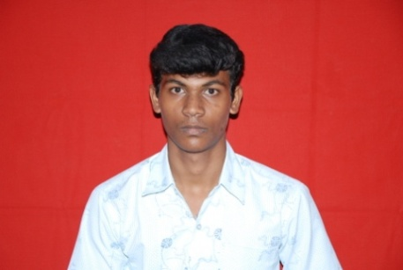 | Name : VIGNESH .G  Address : F/oG.GURUSAMY  2/96 MIDDLE STREET  PALTITHAVANPATTI KEELAKARANTHAI (PO)  VILATHIKULAM(TK)  TUTICORIN 628904  Dob : 03.02.1996  Email Id : gvguru7@gmail.com  Contact no : 8148821433
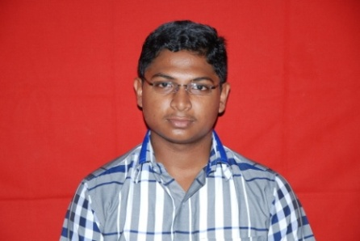 | Name : VIGNESH.R  Address : F/o V.RAMA MOORTHY  17 A TOWN ROAD  THATCHANALLUR  TIRUNELVELI 627358  Dob : 14.11.1995  Email Id : samvignesh1425@gmail.com  Contact no : 8015467668
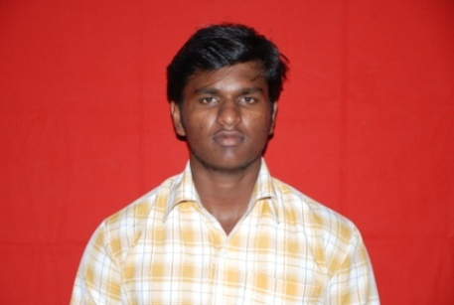 | Name : VIGNESH .S (12.04.1996)  Address : F/o G.SUBRAMANIAN  3A KALIAMMAN KOVIL STREET  KUDIYIRUPPU MELAGARAM VILLAGE  TENKASI(TK)  TIRUNELVELI  Dob : 12.04.1996  Email Id : svignesh1296@gmail.com  Contact no : 9578898542
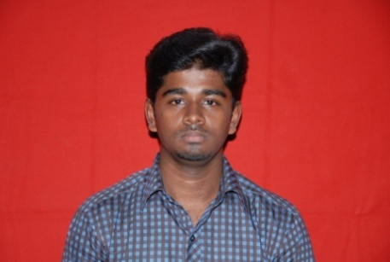 | Name : VIVID PANDIAN.R  Address : F/o S.RAJU  397/51 PALLAK ROAD S.S NAGAR  KOVILPATTI 628501  Dob : 01.03.1996  Email Id : vividimmortal007@gmail.com  Contact no : 9500966276
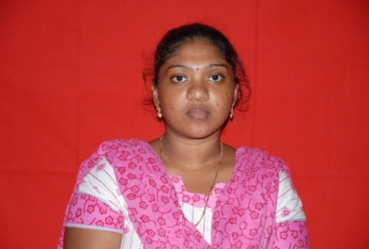 | Name : ARUL MARY.V  Address : D/o V.VINCENT  68 VITAL NAGAR SANKAR NAGAR  TIRUNELVELI 627002  Dob : 12.07.1996  Email Id : arulm674@gmail.com  Contact no : 8148650770
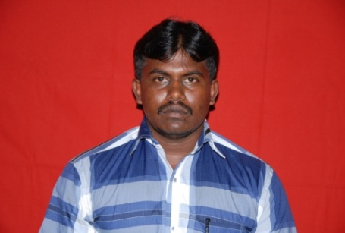 | Name : JEYAKUMAR.B  Address : S/o E.BALA KRISHNAN  4/190 colony street nadu pillayarkulam  TIRUNELVELI 627006  Dob : 08.09.1990  Email Id : kumarhasan140@gmail.com  Contact no : 8508565701
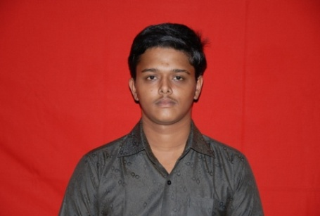 | Name : MAHA SENTHIL GANAPATHY  Address : S/o G.NATARAJAN  652/277 avoc nagar  SUTHAMALLI  TIRUNELVELI 627604  Dob : 22.07.1996  Email Id : nmsenthil96@gmail.com  Contact no : 8807508941
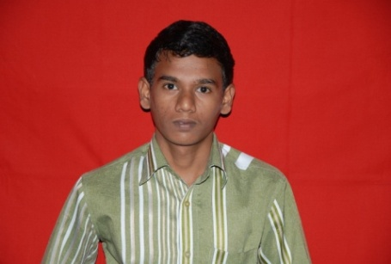 | Name : MANI RATHNAM.G  Address S/o G.GURUSAMY  146 AKKASALAI PILLIAR KOIL STREET  TIRUNELVELI()  OIL STREET TIRUNELVELI(TOWN) 627006:  Dob : 05.01.1997  Email Id : GMR5197@gmail.com  Contact no : 7708778352
 | Name : MANTHIRAMOORTHY.S  Address : S/o S.SUDALAI MARI  155/9 SOUTH STREET  RAJAPATHY GANGAIKONDAN  TIRUNELVELI 627352  Dob : 27.04.1994  Email Id : smoorthy209@gmail.com  Contact no : 9524914955
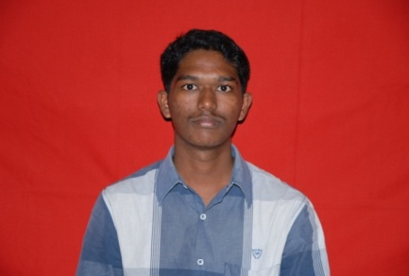 | Name : MURUGESH.P  Address : S/o P.POOTHATHAN  6.ATTHIYADI STREET  KALLIDAI KURICHI AMBAI()  DAIKURICHI AMBAI(TK)  TIRUNELVELI 627416  Dob : 03.05.1993  Email Id : murugesh1993eee@gmail.com  Contact no : 9150484144
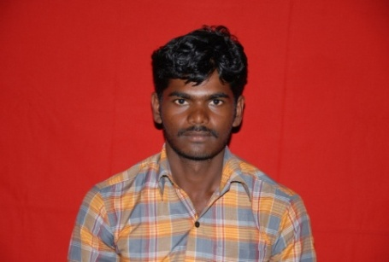 | Name : MUTHU PANDI  Address : S/o S.CHELLA DURAI  1/212 SOUTH STREET  PANIKARKULAM  Dob : 06.07.1992  Email Id : malaiarasan200@gmail.com  Contact no : 9698931852
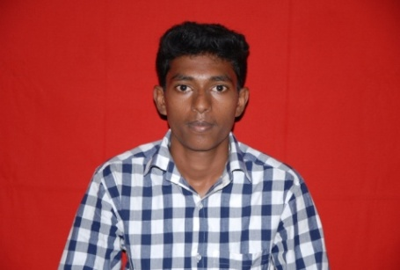 | Name : PALANI KANNAN.R  Address : S/o R.RAJA GOPAL  55 SIVAN WEST CAR STREET  PALAYAMKOTTAI  TIRUNELVELI 627002  Dob : 03.06.1996  Email Id : srigokulamkannan4000@gmail.com  Contact no : 7845859721
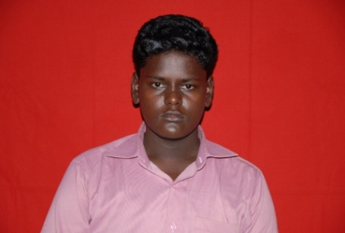 | Name : POORAJA.B  Address : S/o R.BALA MURUGAN  2/21A EAST STREET  AROCKIANATHAPURAM  MAHARAJANAGAR  TIRUNELVELI 627011  Dob : 28.05.1996  Email Id : poorajaeee12@gmail.com  Contact no : 9488201896
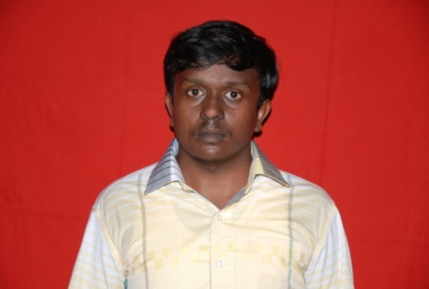 | Name : PRAVIN KUMAR.S  Address : S/o K.SELVARAJ  2/97 CHRUCH STREET ERADUM SOLLAN  ALAGIAPNADIAPURAM (PO)  TIRUNELVELI 627201  Dob : 30.07.1992  Email Id : pravinkumar24@gmail.com  Contact no : 9487603145
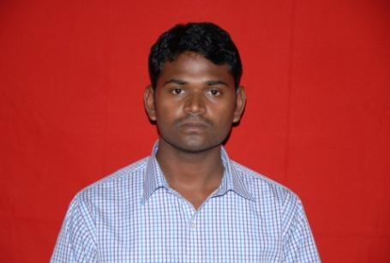 | Name : PREM.C  Address : S/o R.CHANDRAN  19/3 MAVADIKULATHANKARAI  THATCHANALLUR  TIRUNELVELI 627358  Dob : 08.06.1991  Email Id : premwelcome2494@gmail.com  Contact no : 9944192494
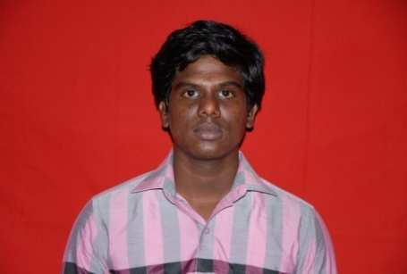 | Name : RAJA.P  Address : S/o V.PERUMAL RAJ  23/1 AMMAN KOVIL STREET  THARAPURAM  Dob : 08.07.1996  Email Id : rajarajan9894@gmail.com  Contact no : 9597608260
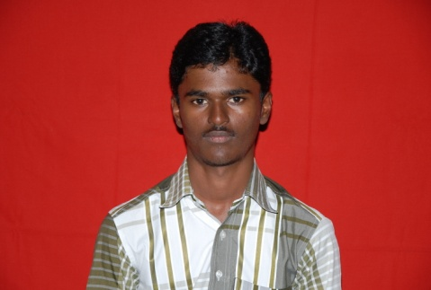 | Name : SAKTHI.M  Address : S/o T.MARIAPPAN  4/9 V.K STREET  VENNILINGA PURAM  VEMKATESHWARAPURAM(PO)  ALANGULAM (TK)  TIRNELVELI  Dob : 29.01.1996  Email Id : mmsathiya@gmail.com  Contact no : 7502762050
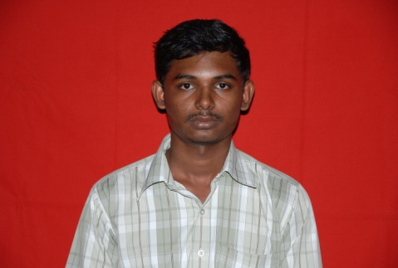 | Name : SURESH.M  Address : S/o MURUGAIAH  2/80 WEST STREET THUTHIKULAM  MAYAMON KURICHI  ALANGANALLUR  TIRUNELVELI 627853  Dob : 17.03.1994  Email Id : sureshiassuresh@gmail.com  Contact no : 9489721992
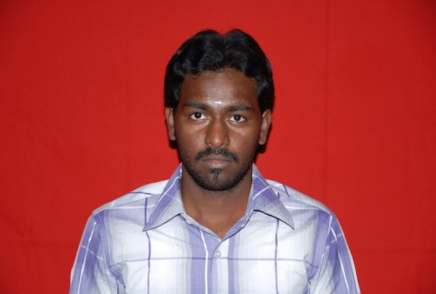 | Name : UDAY KUMAR BALAMURUGAN  Address : S/o A.BALA MURUGAN  ROOM 102 SAHAYADARI NIWAS  KISANNAGAR-3 WAGLE ESTATE  THANE(WEST)  MUMBAI 400604  Dob : 29.10.1993  Email Id : ubm291@gmail.com  Contact no : 9751256718

